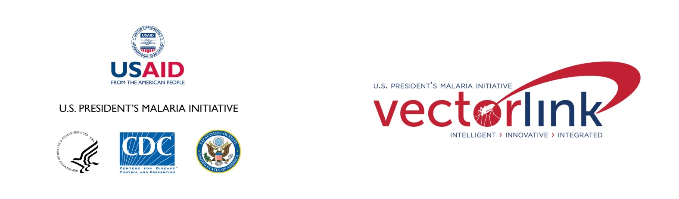

School-based ITN distribution step-by-step exemplar

**Recommended Citation:** The PMI VectorLink Project. November 2020. School-based ITN Distribution Step-by-Step Exemplar. Washington, DC. Population Services International.

**Contract:** AID-OAA-I-17-00008

**Task Order:** AID-OAA-TO-17-00027

**Submitted to:** United States Agency for International Development/PMI

**Submitted on: December 8, 2020**

**Approved on:**

Abt Associates | 6130 Executive Blvd | Rockville, Maryland 20852  
T. 301.347.5000

abtassociates.com



The views expressed in this document do not necessarily reflect the views of the United States Agency for International Development or the United States Government.

Contents

Acronyms 1

1. Introduction 1

2. Steps for Planning and Implementing School-based ITN Distribution 3

3. Step-by-step Template 12

4. Country Profiles 13

Country Template: 13

4.1 TANZANIA: School Net Program (SNP) 15

4.2 GHANA: School-based ITN Distribution 21

4.3 MOZAMBIQUE: School-based ITN distribution Pilot 26

4.4 DEMOCRATIC REPUBLIC of the CONGO: School-based ITN Distribution 30

4.5 GUINEA: School-based ITN Distribution Pilot 35

List of FIGURES

Figure 1: School Net Program Distribution Rounds in PMI Priority Regions in Tanzania 20

Figure 2: Map Showing School-based ITN Distribution Regions in Ghana 25

Figure 3: Map Showing Zambezia Province with Intervention and Control Districts for School Pilot 29

Figure 4: Map showing PMI and partners focus areas in DRC 34

Figure 5: Map showing pilot and control area in Guinea 37

Acronyms

**ANC** Antenatal Care

**DRC** Democratic Republic of the Congo

**EMIS** Education Management Information System

**EPI** Expanded Programme on Immunization

**GES** Ghana Education Service

**GHS** Ghana Health Service

**GHSC-PSM** Global Health Supply Chain – Procurement Supply Management

**ITN** Insecticide-treated Nets

**MoE** Ministry of Education

**MoH** Ministry of Health

**MoHCDGEC** Ministry of Health, Community Development, Gender, Elderly and Children

**M&E** Monitoring and Evaluation

**NMCP** National Malaria Control Program

**PBO** Piperonyl Butoxide

**PMI** U.S. President’s Malaria Initiative

**PNLP** Programme National de Lutte contre le Paludisme

**PO-RALG** President’s Office, Regional Administration and Local Government

**PTA** Parent Teacher Association

**PYP** Person Years of Protection

**SBC** Social and Behavior Change

**SHEP** School Health Education Program

**SISOs** School Inspectorate Support Officers

**SNP** School Net Program

**ToT** Training of Trainers

# Introduction

School-based distribution of insecticide-treated nets (ITNs) was first implemented in Ghana in 2012.[1] Several other countries have since implemented school-based ITN distribution. These experiences are captured in the 2016 *School-Based Distribution of Long-lasting Insecticide Nets*[2] (hereafter “2016 Guide”), a short guide to planning and implementing school-based ITN distribution. The 2016 Guide provides a top-line “how to” on developing a school-based ITN distribution program. It includes best practices and lessons learned from several countries, and outlines the reasons that school-based ITN distribution is an effective continuous ITN distribution channel to achieve and maintain ITN access. Since the publication of the 2016 Guide, more countries have implemented school-based ITN distribution pilots or at scale, generating additional lessons learned for planning and implementing school-based ITN distribution. These experiences and lessons learned are captured in this PMI VectorLink School-based ITN Distribution Step-by-Step Exemplar (hereafter “Exemplar”).

This Exemplar is a consolidated, user-friendly, step-by-step compendium to the 2016 Guide for use by National Malaria Control Programs (NMCPs) and their partners. The purpose of the Exemplar is to explain the process, best practices, and tools needed to design and implement school-based ITN distribution. The Exemplar is intended to streamline and enhance the process and resources provided on [continuousdistribution.org](https://continuousdistribution.org/) for designing, planning, and implementing ITN continuous distribution.

The use of the Exemplar is based on the premise that a NMCP has decided to introduce school-based ITN distribution using the systematic and evidence-based process for channel selection described on [continuousdistribution.org](https://continuousdistribution.org/), including the use of NetCalc.[3] The Exemplar assumes that the NMCP and its partners have determined that school-based ITN distribution is strategic, desirable, and feasible, both logistically and financially, for achieving or maintaining ITN access. The evidence-based process for channel selection described on [continuousdistribution.org](https://continuousdistribution.org/) identifies the criteria necessary for the selection and successful implementation of school-based ITN distribution, such as high enrollment rates for eligible classes, a supportive Ministry of Education (MoE) and Ministry of Health (MoH) (and/or other relevant ministries), and strong subnational MoE structures, among other criterion.

The primary audience for the Exemplar is NMCPs and their partners that are introducing school-based ITN distribution. The secondary audience is NMCPs and their partners that have introduced and implemented school-based ITN distribution but may want to refine their approach or find efficiencies in their current program.

Section 2 of this Exemplar describes a step-by-step process for designing and implementing school-based ITN distribution, based on the recommended steps outlined on [continuousdistribution.org](https://continuousdistribution.org/) for the implementation of continuous ITN distribution, regardless of the distribution channel.

Section 3 consists of a spreadsheet with the steps, activities, tools, and resources for designing and implementing school-based ITN distribution. The spreadsheet can be populated with the names of relevant actors and the timeline for each step and activity. Each step is accompanied by tools and resources developed by countries that have implemented or are currently implementing school-based ITN distribution.

Section 4 contains an up-to-date summary on school-based ITN distribution profiles for Tanzania, Ghana, Mozambique, Democratic Republic of the Congo (DRC), and Guinea. Lessons learned from these countries can inform other countries interested in introducing or improving school-based ITN distribution.

# Steps for Planning and Implementing School-based ITN Distribution

Building on the step-by-step process outlined in [continuousdistribution.org](https://continuousdistribution.org/), the following steps are recommended for planning and implementing school-based ITN distribution.

|  |
| --- |
| **Step 1: Convene a Coordination Committee** |
| **Objective:** Convene a national coordination committee. |
| **Output:** Terms of reference |
| **Activities:**   * In some countries, the national coordination committee may be under the auspices of the NMCP. In some countries, the national coordination committee may be a subcommittee of the national vector control or ITN technical working group. Where a vector control or ITN technical working group already exists, a standalone national coordination committee should not be established. In some countries, especially countries with decentralized systems of government, it may be necessary to establish subnational coordination committees. * Select participants: national and subnational representatives from all government entities and implementing partners involved in planning and implementing school-based ITN distribution, (e.g., MoH, MoE, logistics partners, technical assistance partners). Determine appropriate membership, ensuring representation from all government entities and all implementing partners involved in planning and implementing school-based ITN distribution. * Invite participants. * Conduct the first meeting and develop a terms of reference. * Agree on meeting frequency. During the planning and implementation of school-based ITN distribution, the national or subnational coordination committee should meet formally at least monthly, and may need to meet informally more regularly. Following the completion of school-based ITN distribution, the coordination committee can meet less frequently (e.g., quarterly) until it is time to start planning for the next round of school-based ITN distribution. |

|  |
| --- |
| **Step 2: Develop a Timeline** |
| **Objective:** Develop a detailed timeline listing all tasks required to plan and implement school-based ITN distribution, with realistic time-bound targets and a point person for each task. |
| **Output:** Timeline |
| **Activities:**   * Convene the national coordination committee to prepare the implementation plan. * Develop a school-based ITN distribution implementation plan, including a checklist. * Develop a school-based ITN distribution timeline, including the identification of key steps, an estimated timeline for each step, key milestones, and responsible parties. Planning and implementing school-based ITN distribution is time and labor intensive, so adequate time and human resources should be allotted for each task. It is also important to consider other malaria campaigns (e.g., seasonal malaria chemoprevention, mass ITN distribution) and non-malaria activities (e.g., other activities implemented by the MoE, such as other health interventions, exams) occurring at or around the same time as the planned school-based ITN distribution. If the school-based ITN distribution is planned to occur immediately following or shortly after a mass ITN distribution, national and subnational MoH officials may not have time to dedicate to planning and implementing both distribution activities. This must be borne in mind from the outset to mitigate human resource issues. |

|  |
| --- |
| **Step 3: Develop a Budget** |
| **Objective:** Develop a detailed budget listing all tasks required to plan and implement school-based ITN distribution. |
| **Output:** Budget |
| **Activities:**   * Convene the national coordination committee to prepare the budget for distribution. * Develop a budget template. * Conduct costing exercises and populate the budget template. * Review the budget with key organizational cost leads and validate the budget with the donor, if necessary. |

|  |
| --- |
| **Step 4: Quantify ITN Need** |
| **Objective:** Develop a macro-quantification plan to estimate the number of ITNs required for school-based ITN distribution on an annual basis, and develop a micro-quantification plan to determine the number of ITNs required for each participating subnational level (by region, by district, by school). |
| **Outputs:** Macro-quantification and micro-quantification plans |
| **Activities:**   * Convene the national coordination committee to prepare a macro-quantification plan. * Conduct macroplanning.   + If appropriate, use NetCalc or NetCalc Lite to determine the quantity of ITNs required for distribution through schools to achieve or maintain access.   + Engage the MoH and MoE to obtain class and attendance data.   + Use outputs from NetCalc and enrollment data to determine the classes that are eligible for school-based ITN distribution.   + Validate all decisions with the MoH and the MoE. * Conduct microplanning.   + Use school-level enrollment data to determine the quantity of ITNs required for each eligible school. |

|  |
| --- |
| **Step 5: Create a Logistics and Supply Chain Plan and Prepare for Implementation** |
| **Objective:** Develop a logistics and supply chain plan. |
| **Outputs:** Logistics and supply chain plan including a micro-logistics plan, a storage quality assurance checklist, ITN tracking tools, and class and / or school issuing books and teacher roles reference sheets. |
| **Activities:**   * Convene the national coordination committee to develop or review the logistics and supply chain plan. * Determine forward and reverse logistics.   + For forward logistics, the logistics and supply chain plan should include transport routes, storage points, and distribution points, and it should clearly specify roles and responsibilities for each activity and for all entities involved. It is critical to describe how ITNs will be transported from the port of entry to each eligible school and, if necessary, stored along the way. It is also important to describe how each ITN will be accounted for at each step of the process. If ITNs for school-based distribution are procured by one entity, stored by another entity, and transported by yet another entity, clear roles and responsibilities for each entity need to be established.   + For reverse logistics, the logistics and supply chain plan should include a plan for distributing any remaining ITNs after the conclusion of the school-based ITN distribution and should clearly specify roles and responsibilities for each activity and for all entities involved. The destination of the ITNs remaining after the conclusion of a school-based distribution varies from country to country, (e.g., in Tanzania, ITNs are issued to high achieving pupils in other classes, and in Ghana, ITNs are transferred from schools to nearby health facilities or district stores for distribution through health facility distribution channels) * Develop a warehouse and storage quality assurance checklist. * Develop and produce ITN tracking tools for each level of the health or education system and between levels. Consider whether ITN tracking tools will be paper-based or electronic, and budget accordingly (i.e., electronic ITN tracking tools may require additional training and procurement of electronic devices). If different entities are involved in procurement, storage or warehousing, transportation, and issuing ITNs, involve all entities in the development of ITN tracking tools to ensure an auditable tracking system for each ITN. * Develop, produce, and deliver class and school issuing books and teacher roles reference sheets. If possible, include school issuing books and teacher roles reference sheets during transportation of ITNs to schools so that they arrive with the ITNs, rather than transporting school issuing books and teacher roles reference sheets to schools separately. * Develop a micro logistics plan, including re-bundling ITNs to ensure the appropriate number of ITNs for each school. * Execution of the logistics and supply chain plan may involve collaborating with the national logistics and supply chain entity or contracting a third-party logistics management company (e.g., in Ghana). There are advantages and disadvantages to each approach (Box 1). * Implement the logistics and supply chain plan. |

**Box 1: Advantages and Disadvantages of Using Third-Party Logistics Management Companies for School-based ITN Distribution**

|  |  |
| --- | --- |
| Advantages | Disadvantages |
| **Expertise**: Private sector third-party logistics company’s expertise in logistics.  **Adequate fleets:** Private sector third-party logistics companies own adequate vehicles (i.e., size, quantity, quality) or can easily contract additional vehicles to meet demand.  **Competition**: Private sector third-party logistics companies are contracted through a competitive bidding process, so the lowest-cost proposal with capacity to meet demand will likely be selected.  **Accountability:** Private sector third-party logistics companies are contractually obligated to deliver specific services, by a specific date, with a specific amount of funding. If private sector third-party logistics companies fail to deliver on their contractual obligations, they can be held accountable. | **Lack local context:** Private sector third-party logistics companies contracted centrally may not be familiar with the local context, such as the specific location of schools. Therefore, they may have to rely on local education or health officials to locate the schools.  **Ownership:** Contracting a private sector third-party logistics company may reduce the ownership of school-based ITN distribution by the government (i.e., the government entity responsible for logistics and supply chain management), especially if the third-party logistics contracts are issued by a nongovernmental implementing partner. If the government can issue contracts directly to third-party logistics companies, this may increase ownership. |

|  |
| --- |
| **Step 6: Create an Accountability, Monitoring, and Supervision Plan and Tools, and Implement** |
| **Objective:** Develop an accountability and supervision plan and implement monitoring and supervision activities. |
| **Outputs:** Accountability, monitoring, and supervision plan, and monitoring and supervision tools |
| **Activities:**   * Convene the national coordination committee to develop or review the accountability, monitoring, and supervision plan and tools. * Develop an accountability plan to identify, prevent, and mitigate fraud, theft, and diversion of ITNs at all levels of the system and during all steps. The accountability plan should be linked to the logistics and supply chain plan and the distribution approach proposed to ensure an auditable tracking system for each ITN. Ensuring accountability for each ITN will require coordination among all partners supporting school-based ITN distribution. * Develop a monitoring and supervision plan and monitoring and supervision tools. Numerous levels of monitoring and supervision are required to ensure the successful implementation of school-based ITN distribution. Monitoring and supervision roles and responsibilities should be clearly articulated in the monitoring and supervision plan. Monitoring and supervision tools should be developed for each cadre conducting monitoring and supervision. The tool should correspond with the objectives of monitoring and supervision for each cadre.   + National health and education officials should conduct monitoring visits to a selection of regions, districts, and schools participating in the school-based ITN distribution at least once during the distribution. The primary objective of monitoring visits by national officials is to observe the school-based ITN distribution, support subnational colleagues, and capture lessons learned.   + Regional health and education officials should conduct monitoring visits to a selection of participating districts and schools at least once during distribution. The primary objective of monitoring visits by regional officials is to observe the school-based ITN distribution, support district and sub-district colleagues, and capture lessons learned.   + District health and education officials should conduct monitoring and supervision visits to a selection of participating schools at least once during distribution. The primary objective of monitoring and supervision visits by district officials is to ensure that school-based ITN distribution is implemented as planned, help troubleshoot any challenges, support sub-district and school colleagues, and capture lessons learned.   + In countries where there is an existing cadre of education officials below the district level responsible for monitoring and supervising schools (i.e., School Inspectorate Support Officers in Ghana), sub-district education officials should conduct monitoring and supervision of the schools in their catchment area regularly throughout distribution. The primary objective of supervision and monitoring visits by sub-district officials is to ensure that school-based ITN distribution is implemented as planned, help troubleshoot any challenges, collect data, support school colleagues, and capture lessons learned. * If national, regional, district, or sub-district officials will be reimbursed or otherwise compensated for their monitoring and supervision activities, the monitoring and supervision plan should include a payment plan. The payment plan should include a clear timeline and roles and responsibilities for submitting, verifying, and issuing payments. Where possible, mobile money should be used to reimburse/compensate officials for their monitoring and supervision activities. |

|  |
| --- |
| **Step 7: Develop a Social and Behavior Change Plan and Implement** |
| **Objective:** Develop a social and behavior change (SBC) plan and implement SBC activities. |
| **Outputs:** SBC plan and SBC activities and materials |
| **Activities:**   * Convene the national coordination committee to develop or review the SBC plan. If members of the NMCP SBC team are not usually involved in the coordination committee, they should be invited to the coordination committee meeting to develop or review the SBC plan. * Develop a SBC plan in alignment with the national malaria SBC strategy. The SBC plan should have two primary objectives:   + Ensuring that all eligible students — and their parents — are aware of the school-based ITN distribution: Disseminating information to students and their parents about the purpose, timing, and implementation of the school-based ITN distribution should rely on existing communication channels in the school or sub-district, such as parent teacher associations (PTAs), community radio, existing school communication channels, etc. Information about the purpose, timing, and implementation of school-based ITN distribution should require little tailoring for each school or sub-district, and should be evidence-based. Information should emphasize that the ITN is intended for the household, not necessarily for the student who receives it. Pilot programs have shown that students often feel that the ITNs they receive are “theirs,” even if they already have access to another net.   + Ensuring that all students are aware of the importance of correct and consistent ITN use and ITN care: SBC activities to encourage correct and consistent ITN use and ITN care are more nuanced and complicated. ITN use and ITN care are determined by numerous internal, social, and structural factors, and the SBC activities must be designed to address the factors known to influence ITN use and ITN care. SBC activities to promote ITN use and ITN care may need to be tailored to account for sub-national variation in the factors that influence ITN use or ITN care. SBC activities may need to go beyond simply stating facts about the importance of ITN use or ITN care; for example, the need to specifically address the diverse internal, social, and structural factors that influence ITN use and ITN care. The national malaria SBC strategy likely already mentions the factors known to influence ITN use and ITN care and may also include potential activities that could be adopted for implementation during and after school-based ITN distribution to promote ITN use and ITN care. Where possible, existing communication channels — such as school health talks, school health clubs, school assemblies — should be adapted to address the factors that influence ITN care and ITN use. * Design and produce SBC activities and materials. * Conduct SBC activities: SBC activities should be conducted before, during, and after school-based ITN distribution. Before distribution, it is critical to ensure that all eligible students — and their parents — are aware of the school-based ITN distribution. Before, during, and after distribution, it is important to ensure that all students are aware of the importance of correct and consistent ITN use and ITN care. |

|  |
| --- |
| **Step 8: Develop a Monitoring and Evaluation Plan and Tools, and Implement** |
| **Objective:** Develop a monitoring and evaluation (M&E) plan and tools and implement. |
| **Outputs:** M&E plan, and data collection and reporting tools |
| **Activities:**   * Convene the national coordination committee to develop or review a M&E plan and tools. If members of the NMCP M&E team are not usually involved in the coordination committee, they should be invited to the coordination committee meeting to develop or review the M&E plan and tools. * Develop a M&E plan. The M&E plan should include a logical framework or logic model (where appropriate) and indicators for the school-based ITN distribution. * Determine whether data collection and reporting will occur using an existing data collection and reporting system or a data collection and reporting system specific to school-based ITN distribution. Determine whether data collection and reporting will be paper-based or electronic. Data collection and reporting tools should be developed accordingly. * Budget accordingly. A data collection and reporting system specific to school-based ITN distribution and/ or an electronic data collection and reporting system may require additional training or procurement of electronic devices. |

|  |
| --- |
| **Step 9: Develop an Orientation Training Plan and Tools, and Implement** |
| **Objective:** Develop an orientation and training plan and tools and implement. |
| **Outputs:** Orientation and training plan and agenda, guide, and materials |
| **Activities:**   * Convene the national coordination committee to develop or review an orientation and training plan and tools. * Develop an orientation and training plan: There are unique orientation and training needs for each cadre involved in the school-based ITN distribution. (Box 2: Spotlight on Ghana.) Consider how the orientation and training content should be tailored for each cadre: national health and education officials, regional and district health and education officials, sub-district education officials, health teachers, and class teachers. There are various orientation and training methods that can be used; the approach is likely to be influenced by the context. In some countries and at some levels, virtual orientation and training might be appropriate. For smaller school-based ITN distribution, it may be possible to train everyone directly; however, for larger school-based ITN distribution, it may be necessary to use a training of trainers (ToT) model. Develop an agenda for the orientation meetings. * Develop a training guide and materials: The training guide and materials should clearly describe the roles and responsibilities of each cadre involved in school-based ITN distribution. It should include roles and responsibilities for accountability, issuing ITNs, SBC, monitoring, supervision, data collection and reporting, and reverse logistics. Where possible, adult learning approaches and practical application of knowledge and skills should be used. * Identify trainers. * Identify timing and location of training activities. To reduce the costs associated with training — specifically the identification and contracting of training venues — consider using free or low-cost spaces for training at all levels (e.g., district or sub-district office conference rooms). * Conduct training: If trainers and trainees will be reimbursed or otherwise compensated for conducting or attending a training, the training plan should include a payment plan. The payment plan should include a clear timeline and roles and responsibilities for submitting, verifying, and issuing payments. Where possible, mobile money should be used to reimburse/compensate trainers and trainees for conducting or attending the training. |

**Box 2: School-based ITN Distribution Orientation and Training: Spotlight on Ghana**

|  |
| --- |
| **School-based ITN distribution in Ghana is a collaboration between the Ghana Health Service (GHS) NMCP and Ghana Education Service (GES) School Health Education Program (SHEP). It is supported by donors and implementing partners.**  The **national school-based ITN distribution team** is composed of staff from the NMCP, SHEP, and the U.S. President’s Malaria Initiative (PMI) VectorLink project. The national team is responsible for conducting orientations with the regional teams and supporting the training of the district teams and sub-district School Inspectorate Support Officers (SISOs).  The **regional school-based ITN distribution** **team** is composed of regional SHEP coordinators and GHS regional malaria focal persons. The regional team is a standing team that plans and implements the school-based ITN distribution training every year in which it occurs. The regional team is responsible for training the district teams and sub-district SISOs. The regional team is also responsible for monitoring and supervising the district teams.  The **district school-based ITN distribution team** is composed of the Director of Education, Director of Health, Assistant Director (supervision), district SHEP coordinator, private school coordinator, and the district malaria focal person. The district team is responsible for monitoring and supervising the SISOs.  **SISOs** are responsible for monitoring and supervising ITN distribution at schools and the collection and reporting of school-based ITN distribution data.  The national and regional teams have been involved in school-based ITN distribution since 2013 and, therefore, need only a refresher meeting/orientation in each year of implementation. District teams and SISOs are trained every year in which school-based distribution occurs using the same training guide and materials. The training for the district teams and SISOs includes the following modules: introduction to school-based ITN distribution; overview of malaria; introduction to ITNs; continuous distribution of ITNs; SBC and social mobilization; organizing and managing school-based ITN distribution activities; monitoring and record keeping; roles and responsibilities; and microplanning and logistics. |

|  |
| --- |
| **Step 10: Transport ITNs to the School Distribution Sites** |
| **Objective:** Transport ITNs to eligible schools according to the logistics and supply chain plan. |
| **Outputs:** ITNs delivered to schools |
| **Activities:**   * Determine the timing for the transport of ITNs to schools to minimize storage and warehousing at the subnational or school level. Ideally, ITNs should be delivered to schools for same-day distribution so that they do not need to be stored overnight, which could incur loss or damage. * Develop delivery notes and other documents required for the transport of ITNs from the national to the subnational to the school level. (Reference Step 5: Develop and produce ITN tracking tools for each level of the health or education system and between levels.) Documents required for the transport of ITNs should be prepared by the entity responsible for their delivery. * Manage ITN shortages and excesses during the distribution. Subnational health and education officials who conduct monitoring, supervision, data collection, and reporting activities may be expected to move excess ITNs from schools with a surplus to schools with a shortage of ITNs. |

|  |
| --- |
| **Step 11: Distribute ITNs to Pupils** |
| **Objective:** Distribute ITNs to eligible pupils. |
| **Outputs:** ITNs issued to pupils |
| **Activities:**   * Develop issuing guidance for eligible classes. Issuing guidance should clearly describe the roles and responsibilities for issuing ITNs to pupils; and how to record issuing of ITNs to pupils, aggregatee issuing data, and report issuing data. Typically, the head teacher or class/form teacher is responsible for issuing ITNs and for recording, aggregating, and reporting issuing data. For accountability purposes, it is important to involve more than one teacher at each school in issuing ITNs, and in recording, aggregating, and reporting issuing data. * Issue ITNs in schools on the designated day. Conduct SBC activities, as planned and as described in the SBC plan, to promote correct and consistent ITN use and ITN care. * Conduct monitoring and supervision activities during distribution, as planned and as described in the accountability, monitoring, and supervision plan. * Conduct reverse logistics for any ITNs remaining after school-based ITN distribution, as planned and as described in the logistics and supply chain plan. |

|  |
| --- |
| **Step 12: Analyze Data and Adjust the Future Plan Based on Findings** |
| **Objective:** Identify and document successes, challenges, and lessons learned to inform future school-based ITN distribution planning and implementation. |
| **Output:** Final distribution report |
| **Activities:**   * Collect and analyze training, monitoring, supervision, distribution, and issuing data, and synthesize the successes, challenges, and lessons learned. * Review training, monitoring, supervision, distribution, and issuing data, and successes, challenges, and lessons learned with national and subnational stakeholders. * Organize and hold national and subnational review meetings, if appropriate, to disseminate data, successes, challenges, and lessons learned. * Write and disseminate a final report. |

# Step-by-step Template

Please find below a link to the template that shows the steps, activities, tools, and resources needed for planning and implementing school-based ITN distribution.



# Country Profiles

PMI VectorLink country teams in Tanzania and Ghana were asked to populate the country template shown below based on their experiences implementing school-based ITN distribution. Their experiences are described in Sections 4.1 and 4.2 below. For Mozambique, PMI VectorLink contacted the VectorWorks project and Global Health Supply Chain – Procurement Supply Management (GHSC-PSM), the original implementers, for data and information. For the DRC and Guinea, data were sourced from PMI and materials posted online.

## Country Template:

### List of Partners & Responsibilities

***Increase size of table, as needed***

|  |  |
| --- | --- |
| **Partner** | **Responsibilities** |
|  |  |
|  |  |

### Number of Nets Delivered

***Increase size of table, as needed***

|  |  |  |  |  |  |  |
| --- | --- | --- | --- | --- | --- | --- |
| **Distribution Rounds** | **Year** | **Number of Nets** | **Type of Nets** | **Number of**  **Districts** | **Number of Schools** | **Notes** |
| **TOTAL as of Month Year (where relevant)** |  |  |  |  |  |  |

### Implementation Aids Developed

***Increase size of table, as needed***

|  |
| --- |
| **Documents** |
| **Tools** |
| **Templates** |

### Lessons Learned

|  |
| --- |
|  |
|  |
|  |
|  |

### Evaluations Carried Out (if any) and Key Findings

|  |
| --- |
|  |
|  |

### Costs per nets delivered

***Increase size of table, as needed***

|  |
| --- |
|  |
|  |

### Any additional information

***Increase size of table, as needed***

|  |
| --- |
|  |
|  |

## TANZANIA: School Net Program (SNP)

### List of Partners & Responsibilities

|  |  |
| --- | --- |
| Partner | Responsibilities |
| NMCP/Ministry of Health, Community Development, Gender, Elderly and Children (MoHCDGEC) | Technical ministry, provides implementation guidelines |
| President’s Office, Regional Administration and Local Government (PO-RALG) | Implementing ministry |
| Local Government Authorities | Implementers at Regional and Council levels |
| PMI VectorLink Project | Implementing partner (from mid-2019), responsible for ensuring the distribution of ITNs and data verification of issued ITNs |
| PMI VectorWorks Project | Implementing partner (until mid-2019), responsible for ensuring the distribution of ITNs and data verification of issued ITNs |
| Simba Logistic and Equipment Supply | Private sector third-party logistics company, responsible for ITN transportation to schools |
| Tanzania Communication and Development Centre | SBC |
| Tulonge Afya | SBC |

### Number of Nets Delivered

| Distribution Rounds (Figure 1 on page 20) | Year | Number of Nets | Type of Nets | Number of Districts | Number of Schools | Remarks |
| --- | --- | --- | --- | --- | --- | --- |
| SNP 1 | 2013 | 437,930[4] | Standard | 19 | 2,337 | 3-round pilot in Lindi, Mtwara, and Ruvuma regions, which, at the time, had only 19 councils/ districts. |
| SNP 2 | 2014 | 489,099[5] | Standard | 19 | 2,337 |
| SNP 3 | 2015 | 494,407 | Standard PermaNet 2.0 | 23 | 1,919 |
| SNP 4 | 2016 | 1,133,241 | Standard PermaNet 2.0 | 62 | 5,242 | SNP 4 included 7 regions, which, at the time, had 54 councils/regions. |
| SNP 5 | 2017 | 3,041,419 | Standard PermaNet 2.0 | 105 | 9,540 | SNP 5 included 14 regions. The Global Fund procured 2,095,406 ITNs and PMI procured 946,013 ITNs. |
| SNP 6[6] | 2018 | 2,757,969 | Standard PermaNet 2.0 and Piperonyl butoxide (PBO) PermaNet 3.0 | 105 | 9,540 | SNP 6 included 14 regions. 56,647 of the ITNs distributed were PBO. |
| SNP 7 (Phase 1) | 2019 | 1,260,698 | PBO PermaNet 3.0 | 30 | 3,248 | SNP 7 (Phase 1) included 4 regions. |
| SNP 7 (Phase 2) | 2020 | 1,849,686 | Standard PermaNet 2.0 | 75 | 6,445 | SNP 7 (Phase 2) included 10 regions. |
| SNP 8 | 2020 | 2,253,149 | PBO PermaNet 3.0 and Standard PermaNet 2.0 | 39 | 4,065 | SNP 8 included 1 region. 1,684,793 of the ITNs were PBO. |
| **TOTAL**  **(as of October 2020)** |  | **13,717,598** |  |  |  |  |

### Implementation Aids Developed

|  |
| --- |
| **Documents**   * Implementation Guideline * Training Manual * Teachers’ Reference Sheet * ITN Issuing Book – Class Level * ITN Issuing Book – School Level * ITN Issuing Book – Council Level * ITN Issuing Book – Regional Level |
| **Tools**   * Supervision Checklist * Proof of Delivery * Basic Education Management Information System |
| **Templates**   * Micro planning template * Retirement template |

### Lessons Learned

|  |
| --- |
| **Cost effectiveness:** The economic cost per ITN distributed in SNP 5 was substantially lower than in SNP 3, largely due to cost-cutting measures introduced at national and local levels. Cost-cutting measures included the use of the Basic Education Management Information System as the sole source of enrollment data for SNP 5 instead of paying Ward Executive Officers and District Officers to collect data from each school specifically for SNP 3. Relatedly, SNP 5 relied on a national-level data validation process conducted by the government, rather than each project conducting its own data validation, as was the case for SNP 3. |
| **Weakness in design:** Excluding secondary school students from the target population after SNP 2 meant that households with only older children (in addition to those with no children) were no longer reached by either SNP or antenatal care (ANC)/Expanded Programme on Immunization (EPI) distribution — except through the relatively uncommon event of interhousehold redistribution of ITNs. |
| **Overestimate of net lifetime**: Predictions for ITN use and ownership were somewhat optimistic. One important reason for overestimation was a reliance on an overly optimistic estimate of three years of net lifetime. |
| **Timing of first SNP and interruption in routine delivery:** The 2011 Keep Up Strategy projected the SNP to begin in 2012, but it did not start until mid-2013, nearly three years after the last mass campaign in the three targeted southern regions. |
| **Large number of distribution points:** The large number of schools and hence the number of distribution points for the SNP posed a major operational challenge. The project began with 2,337 primary and secondary school distribution points in 2013, and by 2017, SNP 5 expanded to 9,535 primary school distribution points across the 14 targeted regions. |
| **Improved data centralization**: Through the planning discussions for SNP 1 to SNP 3, the NMCP and PO-RALG centralized the data and improved the systems, allowing both government and implementing partners to access data at the central level. As a result of this collaboration, the SNP helped the PO-RALG formalize data management on enrollment, thereby offering a much-appreciated service. Since SNP 4, classes were pre-identified without costly and time-consuming visits to collect or verify data, and distribution occurred on the same day that the nets were delivered. |
| **Reduced malaria cases in students:** The program reduced malaria cases in the student populations. SNP has also led the PO-RALG, the Ministry of Education and Vocational Training, and the MoHCDGEC to coordinate more closely, which has been an important development in multisectoral malaria control activities. |
| **Quantification of net needs:** In addition to the original modelling that explored the theoretical framework for the SNP, for each SNP round, NetCalc was used to conduct a quantification before net procurement and deployment. Several challenges and some lessons learned through this process led to improvements in the overall quantification modelling process. During SNP 1 to SNP 3, ownership of any ITN was the target used during quantification, whereas population ITN access was used to quantify net needs after SNP 4, resulting in better alignment of planning with national strategic goals. |

### Evaluations Carried Out

|  |
| --- |
| Procedural Audit, 2015 (by the local firm, KAZI) [TZ-ME.3-SNP3-Procedural-Audit-Report-for-VectorWorks-Tanzania-Jan-2016.pdf (continuousdistribution.org](https://continuousdistribution.org/wp-content/uploads/2019/08/TZ-ME.3-SNP3-Procedural-Audit-Report-for-VectorWorks-Tanzania-Jan-2016.pdf)) |
| Evaluation of School Net Distribution Programme, 2016 (By Tulane University/IHI/NMCP)(no electronic copy available). |
| Procedural Audit, 2016 (by the local firm, TIME) (no electronic copy available). |
| Cost Analysis, 2016 (By Tulane University) [ME.3.A.10.-Tanzania SNP5-cost-analysis_USAID-APPROVED.pdf (vector-works.org)](https://www.vector-works.org/wp-content/uploads/ME.3.A.10.-Tanzania-SNP5-cost-analysis_USAID-APPROVED.pdf) |
| Commodity Management Assessment, 2017 (By the local firm, TALEMWA) (no electronic copy available). |

Costs per nets delivered[7]

|  |
| --- |
| Formal costing following standard practices was conducted during SNP 3 and SNP 5. SNP 3 delivered nearly 500,000 ITNs through schools in three regions at a cost of USD $9.48 per ITN distributed (USD $1.58 per person-years of protection (PYP). SNP 5 delivered slightly more than three million ITNs through schools in 14 regions at a cost of USD $3.64 per ITN distributed (USD $0.60 per PYP) in 2017 (including the price of the net). In SNP 3, approximately USD $5.96 of the total costs were for distribution, and the remaining USD $3.52 was the cost of the net itself. By contrast, in SNP 5, approximately USD $1.58 was for distribution, and the remaining USD $2.06 was for the cost of the net itself. |

### Any Additional information

|  |
| --- |
| SNP 1, SNP 2, and SNP 3 were piloted in three regions: Lindi, Mtwara, and Ruvuma. |
| SNP 4 included seven regions: Geita, Kagera, Lindi, Mara, Mtwara, Mwanza, and Ruvuma. |
| SNP 5, SNP 6, SNP 7, and SNP 8 included 14 regions: Geita, Kagera, Katavi, Kigoma, Lindi, Mara, Morogoro, Mtwara, Mwanza, Pwani,, Ruvuma, Shinyanga, Simu, and Tabora. |

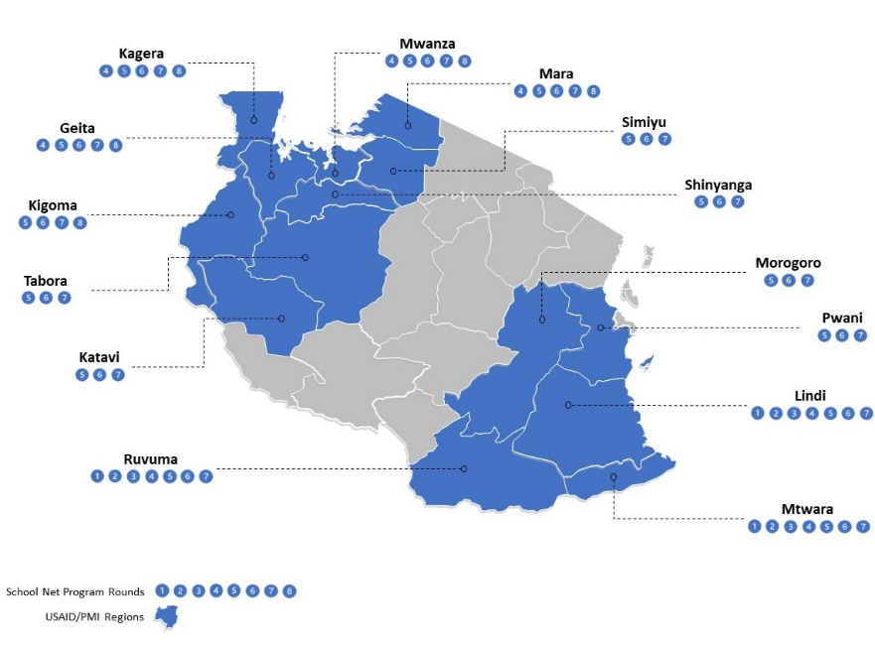

Figure 1: School Net Program Distribution Rounds in PMI Priority Regions in Tanzania[8]

## GHANA: School-based ITN Distribution

### List of Partners & Responsibilities

|  |  |
| --- | --- |
| **Partner** | **Responsibilities** |
| GHS NMCP | Coordinates overall school-based ITN distribution activities at the national level.  Facilitates the link between the GES and implementing partners.  Reviews and approves school enrollment data for ITN stocks to be transported to districts.  Participates in planning, implementation, and supervision of school-based ITN distribution nationwide. |
| GES SHEP national and regional coordinators, district officials, SISOs, and school teachers | SHEP advocates to GES management for the inclusion of school-based ITN distribution as part of the school calendar.  SHEP compiles school enrollment data for ITN stocks to be transported to districts.  Monitor and supervise school-based ITN distribution, and collect and report issuing data.  Distribute ITNs to pupils. |
| PMI VectorWorks project (until mid-2019) and PMI VectorLink project (from mid-2019) | Develop school-based distribution strategy and implementation guidelines with input from all stakeholders. Develop training guides and materials for planning and implementing school-based ITN distribution.  Fund training, monitoring, and supervision. |
| GHSC-PSM and third-party logistics contractors | Overall school-based ITN distribution logistics management.  Warehouse and transport ITNs from national level to district education stores and schools for distribution.  Assist with training, implementation, and supervision of school-based ITN distribution. |

### Number of Nets Delivered

| Distribution Rounds (Figure 2 on page 25) | Year | Number of Nets | Type of Nets | Number of Districts | Number of Schools | Remarks |
| --- | --- | --- | --- | --- | --- | --- |
| 1 | 2012 | 180,000 | Standard | 26 | 2,035 | Included Eastern Region |
| 2 | 2013 | 1,237,200 | Standard | 190 | 18,846 | Included nine regions, except Eastern Region |
| 3 | 2013 | 135,609 | Standard | 26 | 2,052 | Included Eastern Region |
| 4 | 2014 | 1,373,850 | Standard | 216 | 19,245 | Included ten regions |
| 5 | 2016 | 936,357 | Standard | 150 | 16,026 | Included six regions |
| 6 | 2017 | 1,369,206 | Standard | 150 | 23,502 | Included nine regions |
| 7 | 2019 | 1,351,574 | PBO | 196 | 21,541 | Included 15 regions |
| 8 | 2020 | 1,175,249 | PBO | 233 | 26,488 | Included 15 regions |
| **TOTAL as of December 2020** |  | **7,759,045** |  |  |  |  |

Until 2019, Ghana had 10 regions. In 2019, the total number of regions increased to 16. In 2019 and 2020, ITNs were distributed in 15 regions. School-based ITN distribution is not conducted in regions or districts that conduct indoor residual spraying.

### Implementation Aids Developed

|  |
| --- |
| **Documents**   * Training Manual for Primary School ITN Distribution * Standard Operating Procedures for School Distribution 2019 * Draft Implementation Guide (revised August 2020) * VectorWorks Orientation of Key Stakeholders PowerPoint presentation |
| **Tools**   * Net4Schs Application |
| **Templates**   * School Distribution Report Forms A, B, C, D & E |

### Lessons Learned

|  |
| --- |
| **Interministerial collaboration:** Strong collaboration between the GHS and GES contributed to the successful implementation of school-based ITN distribution, including the monitoring, supervision, data collection, and reporting activities. Acceptance of school-based ITN distribution by national and subnational health and education officials is high. |
| **Ghana Education Management Information** **System (EMIS**): Improvements to the EMIS are required to strengthen the quality of school enrollment data available through the system. Engagement with national and subnational EMIS officials is required to ensure that school enrollment data are available and accessible in realtime, or updated early in the school year to avoid the need to use enrollment data from the previous academic year for ITN macro-quantification and micro-quantification. The availability of high-quality school enrollment data can help reduce the oversupply and undersupply of ITNs to schools. |
| **Digitization of data collection:** School-based ITN distribution data collection and reporting by SISOs was digitized through a collaboration between the NMCP and PMI VectorLink. Digitization of data collection and reporting improved the timeliness and accuracy of data collection and reporting. ITN issuing data are now available to national and subnational health and education officials in near real time. |
| **Private schools:** The inclusion of private schools in school-based ITN distribution increases the number of students reached. Private schools will be disenfranchised if only EMIS data are used for macro-quantification and micro-quantification because some private schools are not captured in the EMIS. Consultation with SISOs and district education officials during the microplanning process is critical to ensuring that eligible private schools are included in the school-based ITN distribution. |
| **Existing structures:** Ghana’s SHEP is well-established at national, regional, and school levels. SHEP coordinators at each level are responsible for planning and implementing health activities in schools. Ghana also has a well-established sub-district system of supervisors and SISOs who are responsible for monitoring and supervising 10 to 15 schools on a regular basis. There are more than 26,000 public and private basic primary schools in Ghana. The proliferation of basic primary schools provides a good link between schools and households. (According to the World Bank, net primary school enrollment in 2019 was 86%[9] and gross primary school enrollment was 104%.[10]) PTA meetings are important channels for ensuring community support for school-based ITN distribution and disseminating information before, during, and after school-based ITN distribution. Using existing education structures enables the successful implementation of school-based ITN distribution. |
| **SBC:** SBC activities to promote ITN use and ITN care are conducted before, during, and after school-based ITN distribution. Although ITN use remains suboptimal in Ghana given the access to them, school-based ITN distribution continues to be an opportunity to address barriers, promote facilitators to ITN use and ITN care among pupils, and to encourage pupils to promote ITN use and ITN care in their households with their family members. |
| **PTAs:** PTA meetings are integral to ensuring community support for school-based ITN distribution. PTA meetings are also an important channel for the dissemination of information before, during, and after school-based ITN distribution. The PTA and community outreach programs found that families and children were best reached through drama, songs, and poetry recitals promoting the adoption of positive ITN use and ITN care behaviors. |

### Evaluations Carried Out and Key findings

|  |
| --- |
| Continuous distribution of ITNs through primary schools and health facilities in Ghana: Process evaluation of the pilot in the Eastern Region, 2012. |
| Cost Analysis Series 4: Health Facility and School Distribution in Ghana, 2015-2016[11] |

### Costs per nets delivered

|  |
| --- |
| Per the cost analysis published by VectorWorks in 2018, “the school-based routine distribution system was able to deliver ITNs to schools at an economic cost of USD $4.31 per net distributed in 2016”. Of these costs, approximately USD $1.61 was for distribution, and the remainder, of USD $2.70, related to the cost of the net itself. For school-based ITN distribution, the most significant cost driver in financial terms was the price of ITNs, including cost, insurance, and freight. The second most important cost drivers were the expenditures on personnel and fringe; the third most important cost drivers were the expenditures on supervision, monitoring, and evaluation. |

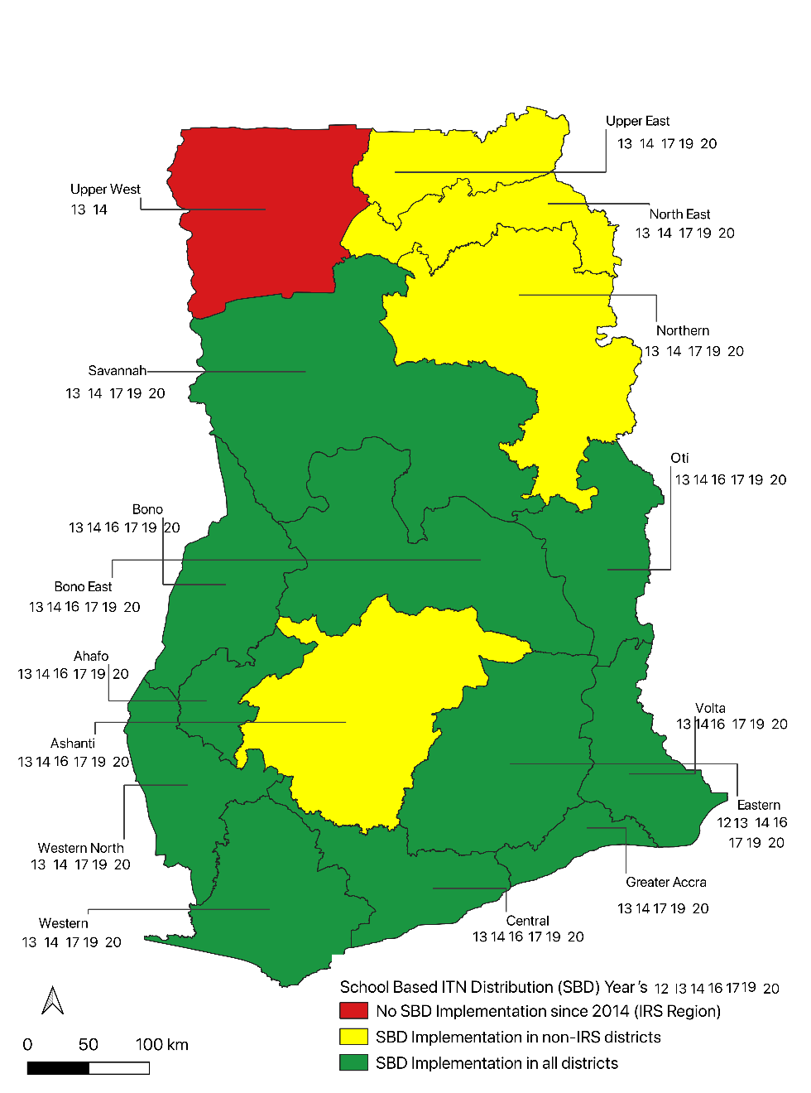

**Figure 2: Map Showing School-based ITN Distribution Regions in Ghana[12]**

## MOZAMBIQUE: School-based ITN distribution Pilot

### List of Partners & Responsibilities

|  |  |
| --- | --- |
| Partner | Responsibilities |
| PMI VectorWorks Project | Supported the NMCP and PMI in coordinating the implementing partners for the first round of the school-based ITN distribution pilot.  Provided resources, technical assistance, and reference materials to partners for developing planning tools.  Worked with the NMCP and partners to finalize distribution, reporting, and supervision tools.  In collaboration with the NMCP and GHSC-PSM, VectorWorks also planned for and implemented microplanning and a ToT.[13] |
| NMCP | Coordination and implementation activities |
| MoH | Coordination |
| MoE | Coordination |
| GHSC-PSM | Logistics |

### Number of Nets Delivered

| Distribution Rounds (Figure 3 on page 29) | Year | Number of Nets | Type of Nets | Number of Districts | Number of Schools | Remarks |
| --- | --- | --- | --- | --- | --- | --- |
| 1 | 2018 | 26,690 [14] | Standard | 1 | 134 primary schools | Namarroi District (intervention district) (Mulevala District was included as a control district) |
| 2 | 2019 | 30,000 | Standard | 1 | 134 primary schools | Namarroi District (intervention district) (Mulevala District was included as a control district) |
| **TOTAL** |  | **56,690** |  |  |  |  |

### Implementation Aids Developed

|  |
| --- |
| **Documents**   * School distribution microplanning tools * Supervision tools * Visual aid for ITN brand identification[15] |
| **Tools**   * Sheet 6-A, Sheet 6-B, Compatibility report * Sheet with photos of the campaign brand of ITN and other common ITN brands |
| **Templates**   * ITN transportation assessment, Distribution by classes (1,3,5), Comparison sheet, Supervision sheet, Supervision budget, Training cascade |

### Lessons Learned

|  |
| --- |
| **Project costs:**. It is important to compare cost efficiencies of school-based ITN distribution at different scales, such as nationwide or subnational school-based ITN distribution, especially in areas where schools are disparate or have low enrollment, and to measure the impact on health and education outcomes. |
| **ITN access:** It will be important to collect information on whether ITNs are redistributed both in and outside of households, especially the rates of interhousehold distribution of excess ITNs in a range of settings. This information will be useful to countries to know whether their chosen mix of distribution channels may leave some subgroups of the population with low access to ITNs. |
| **Continuous distribution:** Continuous school-based ITN distribution was found to be both feasible and useful when compared with annual school-based ITN distribution. Continuous school-based ITN distribution should be tracked by the implementors and lessons learned should be disseminated by the implementors to relevant stakeholders and international communities of practice. It was noted that MoE capacity was limited and considerable effort will be required to coordinate, implement, and monitor school-based ITN distribution as a continuous event. |
| **Clustering schools:** It was not feasible to cluster schools with one school designated as the distributor in areas with limited infrastructure (i.e., quality of the roads).Involving parents in the activities of their own community’s school is important to strengthen the linkage among teachers, the school, and parents, and to increase ownership of school-based ITN distribution. |
| **Integration of activities:** The feasibility and potential for cost efficiencies from integrating school-based ITN distribution to other school health activities, such as the distribution of medications for deworming, may be possible. Further cost analysis should be conducted. Integration of school-based ITN distribution and other school health activities will require considerable coordination. |
| **School councils:** School councils are an existing structure at each primary school, comprised of the school director, teachers, fathers, and community leaders. Due to their influence and reputation, school councils were found to be more effective change agents for promoting ITN use in the community than pupils alone. |
| **Appropriate timing:** School-based ITN distribution should follow mass ITN distribution, either before or after the rainy season, and school-based ITN distribution should not be conducted during the busiest time of the year in the farming season. |

### Evaluations Carried Out/Key findings

|  |
| --- |
| Mozambique School-based ITN Distribution Pilot: Baseline Evaluation in Namarroi and Mulevala Districts, Zambezia Province 2018/2019.   1. Two annual rounds of school-based ITN distribution to three classes of primary school students in a rural district in Zambezia province significantly contributed to sustaining the ITN coverage obtained through the previous mass ITN distribution campaign. 2. Follow-up done only two years post-campaign was too short to allow any definite statements about the feasibility of the school channel to sustain universal ITN coverage without further mass campaigns. However, the findings suggest that this approach, in combination with SBC on positive net care behaviors, could be a promising element in a continuous ITN distribution strategy. If school distribution is only considered as an additional channel between mass campaigns every three years, then the findings suggest that school distributions are a feasible way to reduce the pre-campaign trough in coverage by 24 percentage points. 3. After two years, no differences in ITN coverage were found between intervention and control districts. This was due to “unintended interventions” in the control district of higher access to ANC and EPI ITNs, and higher retention of campaign ITNs, most likely due to better net care behavior. However, the data suggest that increasing differences would be seen in the following years without further campaign distributions. |

### Costs per nets delivered

|  |
| --- |
| The distribution cost for the first distribution cycle (2018) was USD $3.89 per ITN. The distribution cost for the second distribution cycle (2019) was USD $1.81 per ITN.  In general, the activity costs decreased from USD $107,563.57 for the first distribution cycle (2018) to USD $50,648.96 for the second distribution cycle (2019). The primary reasons for the decrease in the distribution costs per ITN and total activity costs from the first distribution cycle to the second distribution cycle were:   * The training for the second distribution cycle was a refresher training (i.e., fewer days and less intense because all trainees were trained the previous year). * There were fewer monitoring visits from the central level to the intervention district during the second distribution cycle than during the first distribution cycle. |

### Any Additional information

|  |
| --- |
| Following the conclusion of the second distribution cycle in 2019, the NMCP decided not to proceed with national or subnational school-based ITN distribution. |

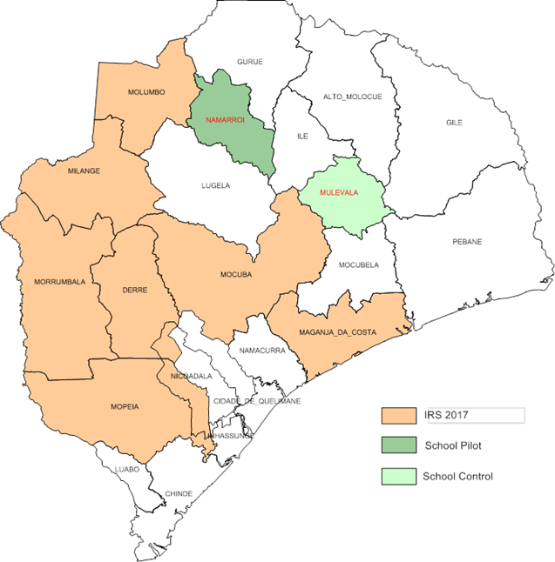

Figure 3: Map Showing Zambezia Province with Intervention and Control Districts for School Pilot[16]

## DEMOCRATIC REPUBLIC OF The CONGO: School-based ITN Distribution

### List of Partners & Responsibilities

|  |  |
| --- | --- |
| Partner | Responsibilities |
| PMI VectorWorks project | In 2017, PMI provided technical assistance to the NMCP and partners to develop guidelines for school-based ITN distribution that will serve as standard planning, implementation, and evaluation guides.[17]  Provided a detailed list of information to be considered for site assessments, which will feed into provincial implementation plans.  Provided a template/guidance for the provincial-level implementation plans (micro plans), which mirrors the national implementation guide, and includes guidelines for a budget, logistics plan, and quantification guidance.  Provided long-distance technical assistance to review provincial implementation plans, as needed. |
| United Nations International Children’s Emergency Fund | Responsible for leading implementation and writing the provincial implementation guides. |
| Programme National de Lutte contre le Paludisme (PNLP) | Sent supervisors to the provincial level to initiate the school-based ITN distribution planning process.  Provided technical support for data collection. |
| MoH | Provided technical support for data collection.  Supervised training at district and central levels. |
| Ministry of Primary and Secondary Education[18] | Sent supervisors to the provincial level to initiate the school-based distribution planning process in collaboration with the PNLP.  Oversaw all stages of implementation at the provincial level (provincial education coordinators), in collaboration with the PNLP and partners.  Oversaw training, planning of school-based ITN distribution, and the monitoring and supervision of school-based ITN distribution implementation.  Conducted SBC activities, specifically disseminating information from trained teachers to students at assemblies and in classes. |
| SanRu | Conducted SBC activities. |
| Territorial supervisors and the parents’ committees | Identified distribution bottlenecks and took corrective actions. |

### Number of Nets Delivered

|  |  |  |  |  |  |  |
| --- | --- | --- | --- | --- | --- | --- |
| Distribution Rounds (Figure 4 on page 34) | Year | Number of Nets | Type of Nets | Number of Districts | Number of Schools | Remarks |
| 1 | 2014–2015 | 380,004[19] | No information found | 12 Health Zones selected: six intervention and six control | 1,094[20] | Pilot in Kasai Central Province |
| 2 | 2017–2018 school year | **―** | **―** | **―** | **―** | Tanganyika Province |
| 2017–2018 school year | **―** | **―** | **―** | **―** | Lualaba Province |
| 2017–2018 school year | **―** | **―** | **―** | **―** | Lomami Province |
| **TOTAL as of July 2020** |  | **380,000** |  |  |  |  |

### Implementation Aids Developed

|  |
| --- |
| **Documents**   * Timeline for school-based ITN distribution showing the list of activities/tasks and expected results * Checklist for planning for the implementation of continuous ITN distribution * Detailed budget model for school-based ITN distribution * Storage assessment * Communication Plan for School-Based ITN Distribution * Logical framework for ITN distribution approach across primary schools * Continuous Distribution Assessment Survey * Pre/post school distribution training test * Preliminary transportation plan * Delivery/reception slip and stock card * Classroom distribution sheet |
| **Tools**   * Fact sheets to support activities * Message matrix showing target audience, communication goals, key messages, and message delivery channels * Questionnaire |
| **Templates**   * Budget template, including budget details, budget parameters showing per diem rates, transportation rates, photocopy costs, etc., name and title of participants, planning, ITN transfer, implementation, dissemination * Information sheet – school-based distribution of ITNs * Information sheet – prevention of malaria * Form A – to be completed by the teacher during distribution * Form B – to be completed by the principal after distribution * Form C – to be completed by the Sub Proved after school distribution * Form D – to be filled by the Proved after school distribution |

### Lessons Learned

|  |
| --- |
| **Lack of evidence:**   * No baseline evaluation was conducted following the 2014 mass campaign in Kasai Central and, therefore, it was very challenging to determine the effects of the school-based ITN distribution on the targeted zones. * Neither the evaluation nor the implementation team demonstrated the added value of school-based ITN distribution on malaria prevention or malaria incidence in Kasai Central. * This school-based ITN distribution was implemented in conjunction with a community-based ITN distribution that targeted pregnant women who did not attend ANC or who did not deliver at a health facility, and children who had not completed their vaccination schedule. Therefore, it is difficult to assess the impact of school-based ITN distribution versus the concurrent community-based ITN distribution. |
| **Timing:** The beginning of this school-based ITN distribution pilot started six months following the mass campaign (mass distribution: November 2014, school-based ITN distribution pilot: June 2015). However, the school-based ITN distribution pilot did not follow the recommended school-based one-time distribution; instead, distribution took place in target schools over the course of more than one year. The duration of this activity was from April 2015 through March 2017, when the evaluation was concluded. |
| **Poor extrapolation of data:** At one school, the director and assistant director conducted their own “study” to determine whether the distribution affected absenteeism. They concluded that because fewer students were missing class due to fever post-distribution, the distribution was successful and led to less absenteeism across the province. |
| **Collaboration/partnership:** Little detail was provided as to the level of collaboration and partnership between the health and education sectors. It appears that the education sector was involved in meetings, but perhaps not in decision making. |
| **Buffer stock of ITNs:** It is essential to provide a reserve stock of ITNs, both in macro-quantification plans and in micro-quantification plans, in case there are unexpected demands or data errors. |

### Evaluations Carried Out and Key Findings[21]

|  |
| --- |
| Before the campaign, a rapid assessment of the availability and use of ITNs in the community was conducted to provide basic data. |
| During the campaign, internal monitoring was carried out by the territorial supervisors and the parents’ committee to identify bottlenecks and take corrective actions. |
| At the end of the campaign, external monitoring was carried out by an independent institution to assess the quality of the intervention and the level of availability and use of ITNs. |
| Assessments, such as a pre-/post-school distribution training test, should be carried out before and after training to ensure that trained individuals have understood the program. |

### Costs per nets delivered

|  |
| --- |
| Not known. According to a FY 2016 PMI DRC Malaria Operational Plan reprogramming memo, the 380,000 ITNs were procured at USD $3.00 per ITN. |

### Any Additional information

|  |
| --- |
| The school-based ITN distribution consisted of distributing one free ITN to each student in grades 1, 3, and 5 in primary schools, and to each member of the teaching staff in recipient schools. |
| In terms of SBC, messages should emphasize that ITNs are intended for the household, not necessarily for the students who receives them. As with distribution in health facilities, it is the household that decides how to distribute its ITN. Pilot programs have shown that students often feel that the ITNs they receive are “theirs,” even if they already have access to another mosquito net. |

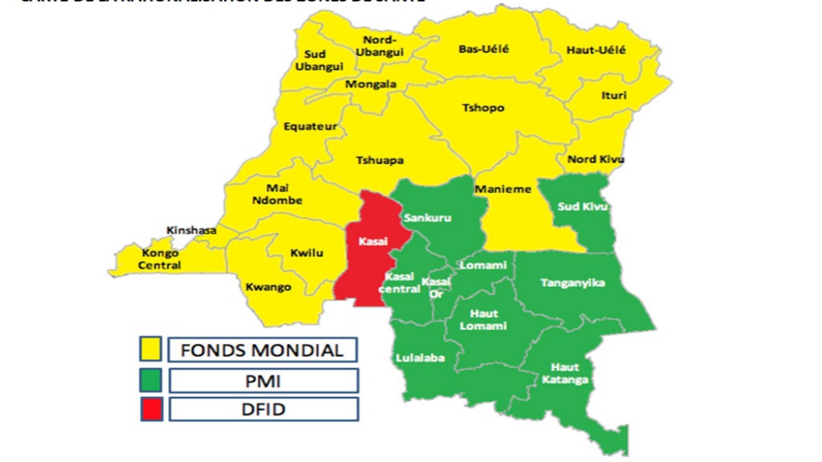

**SCHOOL PILOT DISTRICTS**

Figure 4: Map showing PMI and partners focus areas in DRC[22]

## GUINEA: School-based ITN Distribution Pilot

### List of Partners & Responsibilities

|  |  |
| --- | --- |
| Partner | Responsibilities |
| PNLP | SBC  Logistics management  Led ToT in collaboration with the PMI VectorWorks project in Boffa |
| PMI VectorWorks Project | Implementing and coordinating partner for this activity  Led ToT in Boffa |
| PMI | Funding and planning |
| GHSC-PSM Guinea | Distribution |
| MoE /Office of School Health | Distributing ITNs to students in classrooms |

### Number of Nets Delivered

|  |  |  |  |  |  |  |
| --- | --- | --- | --- | --- | --- | --- |
| Distribution Rounds | Year | Number of Nets | Type of Nets | Number of Districts | Number of Schools | Remarks |
| 1  (**Figure 5 on page 37**) | 2018 | 20,488 | Standard | 1 | 182 primary schools | Pilot in Boffa region[23] |

### Implementation Aids Developed

|  |
| --- |
| **Documents**   * Surveillance checklist for daily monitoring of continuous distribution in schools * Micro Programme script * Technical fact sheet – round table organization * Autocollant Pour Les Eleves * Classroom posters * Continuous distribution surveillance forms – Checklist for daily monitoring * Training guide for the school distribution of ITNs in Boffa prefecture |
| **Tools**   * No information found |
| **Templates**   * No information found |

### Lessons Learned

|  |
| --- |
| **Religious leaders:** Include religious leaders well before distribution occurs to allow for better coordination of messages and increase the number of messages shared in mosques and churches.[24] |
| **Communications strategy**: The local coordination committee provided important information on key channels (community health agents, local radio, PTAs, and religious groups) to transmit messages, but it was recommended that if budget and timelines permit, more key informant interviews and focus groups could improve the communications strategy. |
| **Scale-up:** If Guinean malaria authorities decide to continue with scaled up school-based ITN distribution, then the national coordination committee will probably not be able to provide as much quality assurance; instead, prefectural and regional coordination committees would be responsible. |
| **Post-distribution spot checks:** Distribution organizers felt that increased supervision during distribution would be difficult to achieve. It was recommended that in the future, more post-distribution spot checks should be performed to validate high-quality distribution across the district. |

### Evaluations Carried Out/Key findings[25]

|  |
| --- |
| In May 2018, a cross sectional household survey was conducted to evaluate the school-based ITN distribution pilot in partnership with a local research firm, Cabinet d’Études, de Recherches et de Conseils.   * 56% of households in the Boffa area received information on the net distribution in primary schools compared with 3% in Dubreka, the control region. * Of all nets surveyed, 9% were from the primary school distribution as opposed to 82% from mass campaigns, and 5% from ANC. * Among all ITNs considered in the survey, 64% of nets were used in Boffa compared with 58% in Dubreka. |

### Costs per nets delivered

|  |
| --- |
| Not known. |

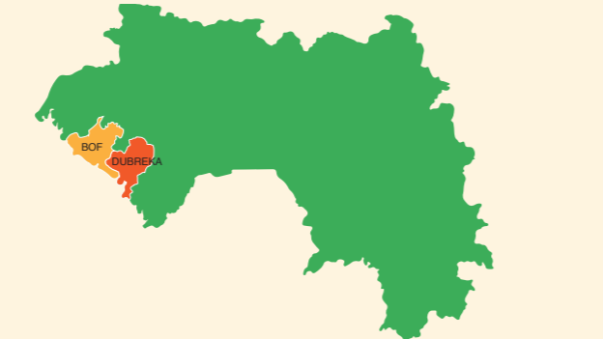

**FA**

Pilot District



 Control District

Figure 5: Map showing pilot and control areas in Guinea[26]

1. De Beyl, Celine Zegers, et al. “Impact of a 15-Month Multi-Channel Continuous Distribution Pilot on ITN Ownership and Access in Eastern Region, Ghana.” *Malaria Journal*, vol. 17, no. 1, 2018, <https://doi.org/10.1186/s12936-018-2275-8>.
2. Kolaczinski, Kate. U.S. President’s Malaria Initiative VectorWorks Project, Updated December 2016, *School-Based Distribution Of Long-Lasting Insecticidal Nets: A Short Guide Based On Recent Country Experience.*, [www.continuousdistribution.org/wp-content/uploads/2017/02/School-Based-Distribution-of-Long-Lasting-Insecticidal-Nets-2016.pdf](http://www.continuousdistribution.org/wp-content/uploads/2017/02/School-Based-Distribution-of-Long-Lasting-Insecticidal-Nets-2016.pdf).
3. “NetCALC/NetCALC Lite Planning Tool.” *VectorWorks*, U.S. President’s Malaria Initiative VectorWorks Project, 17 Sept. 2019, [www.vector-works.org/resources/netcalc-planning-tool/](http://www.vector-works.org/resources/netcalc-planning-tool/).
4. RBM VCWG, and Tanzania NMCP. U.S. President’s Malaria Initiative, *Continuous LLIN Distribution Piloting School Net Distribution in Mainland Tanzania*, [www.pmi.gov/docs/default-source/default-document-library/implementing-partner-reports/tanzania3_networks.pdf?sfvrsn=6](http://www.pmi.gov/docs/default-source/default-document-library/implementing-partner-reports/tanzania3_networks.pdf?sfvrsn=6).
5. Tanzania Institute of Monitoring and Evaluation. 2017, *Process Evaluation of School Net Program Round 4.*
6. *School Net Program (SNP6) Final Report,* U.S. President’s Malaria Initiative, 2018.
7. Yukich, Joshua, et al. “Sustaining LLIN Coverage with Continuous Distribution: the School Net Programme in Tanzania.” *Malaria Journal*, vol. 19, no. 1, 2020, <https://doi.org/10.1186/s12936-020-03222-8>.
8. Source U.S. President’s Malaria Initiative, VectorLink Project
9. “School Enrollment, Primary (% Net) – Ghana.” *Data*, The World Bank, Feb. 2020, <https://data.worldbank.org/indicator/SE.PRM.NENR?locations=GH>.
10. The “School Enrollment, Primary (% Gross) – Ghana.” *Data,* The World Bank, Sept. 2020, <https://data.worldbank.org/indicator/SE.PRM.ENRR?locations=GH>.
11. Scates, Sara, and Joshua Yukich. U.S. President's Malaria Initiative, VectorWorks Project, *Cost Analysis Series 4: Health Facility and School Distribution in Ghana, 2015-2016*, [www.vector-works.org/wp-content/uploads/ME.3.A.3-Ghana-ITN-CD-Costing-Report-2018-9-11_USAID-APPROVED.pdf](http://www.vector-works.org/wp-content/uploads/ME.3.A.3-Ghana-ITN-CD-Costing-Report-2018-9-11_USAID-APPROVED.pdf).
12. Source: PMI VectorLink Ghana
13. Johns Hopkins Center for Communication Programs. U.S. President’s Malaria Initiative, VectorWorks Project, 2018, *The VectorWorks Project* *Year 4 Semiannual Report: October 1, 2017–September 30, 2018*.
14. U.S President’s Malaria Initiative, *Ensuring Continuous Access to Bed-nets through Primary Schools.*
15. Mozambique – Final evaluation report
16. Source: MZ.7.C.9. Dissemination Workshop Presentation (VectorWorks).
17. U.S. President’s Malaria Initiative. “DRC Malaria Operational Plan FY 2018.” *PMI.gov,* 2018, [www.pmi.gov/docs/default-source/default-document-library/malaria-operational-plans/fy-2018/fy-2018-democratic-republic-of-the-congo-malaria-operational-plan.pdf?sfvrsn=5](http://www.pmi.gov/docs/default-source/default-document-library/malaria-operational-plans/fy-2018/fy-2018-democratic-republic-of-the-congo-malaria-operational-plan.pdf?sfvrsn=5).
18. U.S. President’s Malaria Initiative, 2017*.* *Democratic Republic of the Congo LLIN School Distribution – Implementation Guide.*
19. U.S. President’s Malaria Initiative. “DRC Malaria Operational Plan FY 2017.” *PMI.gov,* 2017, [www.pmi.gov/docs/default-source/default-document-library/malaria-operational-plans/fy17/fy-2017-democratic-republic-of-congo-malaria-operational-plan.pdf?sfvrsn=19](https://www.pmi.gov/docs/default-source/default-document-library/malaria-operational-plans/fy17/fy-2017-democratic-republic-of-congo-malaria-operational-plan.pdf?sfvrsn=19).
20. U.S. President’s Malaria Initiative, 2017*.* *Democratic Republic of the Congo LLIN School Distribution – Implementation Guide.*
21. Berthe, S. U.S. President’s Malaria Initiative, VectorWorks Project, Mar. 2017, *VectorWorks Project Trip Report DRC.*
22. U.S. President’s Malaria Initiative. “DRC Malaria Operational Plan FY 2017.” *PMI.gov,* 2017, [www.pmi.gov/docs/default-source/default-document-library/malaria-operational-plans/fy17/fy-2017-democratic-republic-of-congo-malaria-operational-plan.pdf?sfvrsn=19](https://www.pmi.gov/docs/default-source/default-document-library/malaria-operational-plans/fy17/fy-2017-democratic-republic-of-congo-malaria-operational-plan.pdf?sfvrsn=19).
23. “Evaluation of Guinea Insecticide Treated Net School Distribution Pilot.” *Continuousdistribution.org*, <https://continuousdistribution.org/wp-content/uploads/2019/01/GN.5-Pilot-Infographic-EN-.pdf>.
24. U.S President's Malaria Initiative, VectorWorks Project, Nov. 2018. *Guinea School ITN Distribution Pilot Report And Evaluation.*
25. VectorWorks Project, *Guinea School ITN Distribution Pilot Report And Evaluation.*
26. Evaluation of Guinea Insecticide Treated Net School Distribution Pilot.” *Continuousdistribution.org*, <https://continuousdistribution.org/wp-content/uploads/2019/01/GN.5-Pilot-Infographic-EN-.pdf>.